const int sensorMin = 0;
const int sensorMax = 1024;

void setup() {
Serial.begin(9600);
}

void loop() {
int sensorReading = analogRead(A0);

int range = map(sensorReading, sensorMin, sensorMax, 0, 3);

switch (range) {
case 0:
Serial.println("RAINING");
break;

case 1:
Serial.println("RAIN WARNING");
break;

case 2:
Serial.println("NOT RAINING");
break;
}

delay(1000);
}
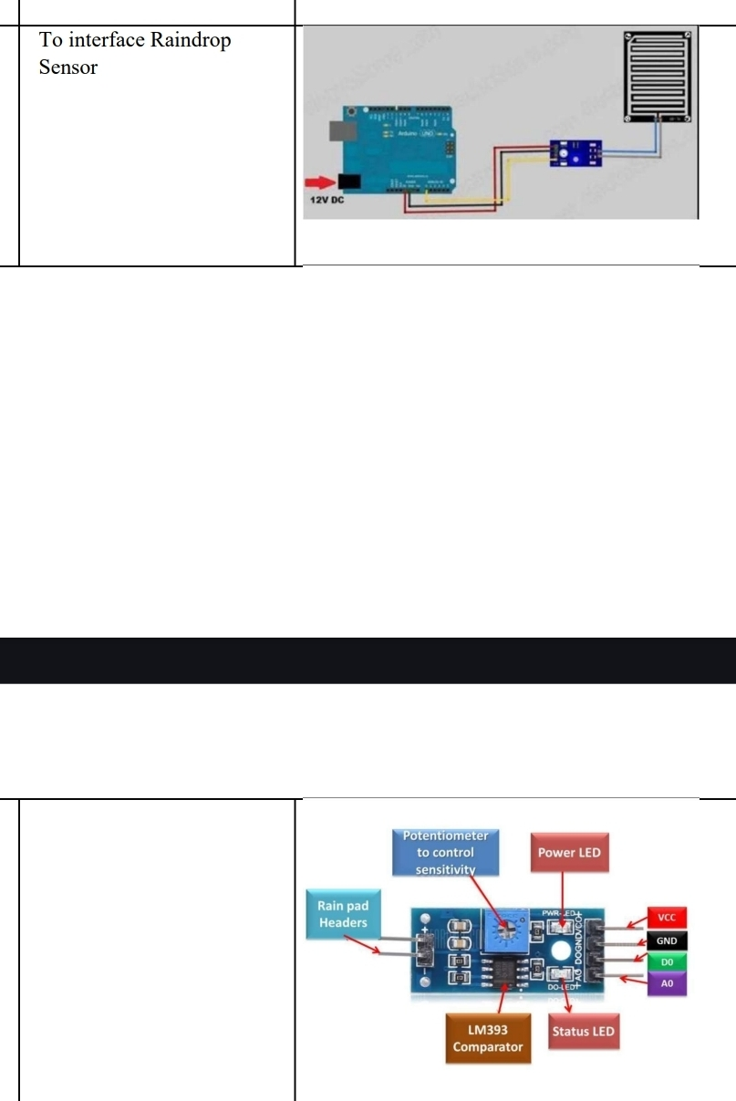
VCC → 5V
• GND → GND

• AO → A0

